The Letter to the Galatians
P1 Background and Context

How does the Book of Galatians fit into the Bible?

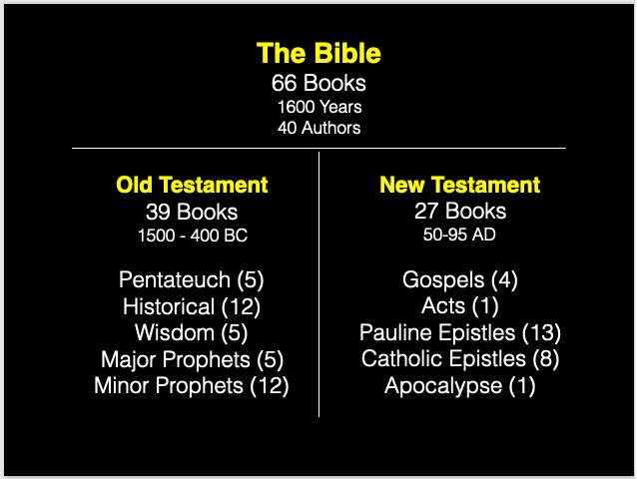

The Letter to the Galatians
Written by the Apostle Paul in A.D. 49 from Antioch, Syria.

Map of ALL Paul’s Travel. He traveled more than 10,000 miles on foot during his ministry...

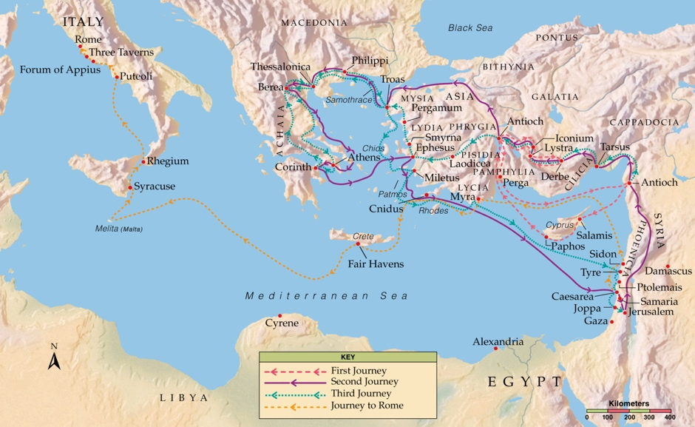
Paul’s First Missionary Journey
His first missionary journey covered 1400 miles leaving from his home church in Antioch Syria and returning there 4-10 months later.

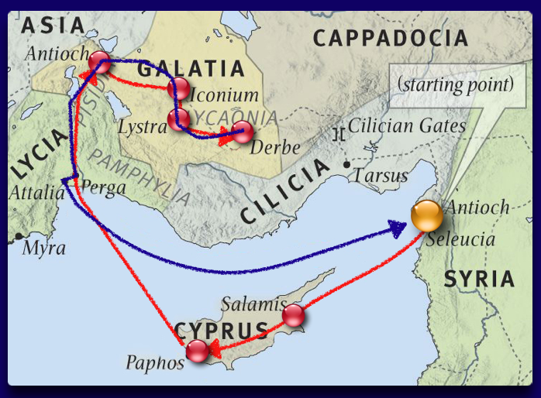

About the Region
Galatia--A Region in Asia Minor (Modern Day Turkey) a Province of Rome

Galatians--the name given to this Celtic People because they migrated to Asia Minor from Gaul.

‘ProGlatas’ --To the Galatians--The only letter of Paul that is specifically addressed to a number of churches.

A Summary of Paul’s Experience
ACTS 13:1-14:28

Antioch Syria --Paul and Barnabas Sent Out By Holy Spirit

Paphos --Encountered a Sorcerer posing as a Prophet.

Perga --John Mark Leaves the Team

Antioch Pisidia --Gentiles Glorify God While Jews Kick Paul Out of Town after Whole City Hears Gospel

Iconium --Signs & Wonders--Uncovered a Plot to Kill Paul & Barnabas. He Fled to Lystra

Lystra --A Lame Man Healed--First Deified, Then Stoned

Derbe --Made Many Disciples & Established Churches

Antioch Syria --Paul Returns Home & Debriefs the Church

Theme of Galatians = Freedom
Freedom from Legalism and Sin brings Liberty.

Chapters 1 & 2: Paul Defends the Gospel of Grace
The Gospel of Grace is the only gospel; It comes from God and not from men. The Gospel of Grace justifies and unites the body of Christ.

Chapters 3 & 4: Paul Explains the Gospel of Grace
Through faith, we are made righteous, set free from sin and the law. Faith sets us free from slavery and makes us sons and daughters –no longer slaves.

Chapters 5 & 6: Paul Applies the Gospel of Grace
We have been set free and remain free by walking in the Spirit. True spirituality is demonstrated in our ability to get along with people and our stewardship of the money and resources He gives us.

Key Verses from the Book of Galatians:
...knowing that a man is not justified by the works of the law but by faith in Jesus Christ, even we have believed in Christ Jesus, that we might be justified by faith in Christ and not by the works of the law; for by the works of the law no flesh shall be justified. Galatians 2:16

“Christ has redeemed us from the curse of the law…that the blessing of Abraham might come upon the Gentiles in Christ Jesus, that we might receive the promise of the Spirit through faith.” Galatians 3:14-15

“Stand fast therefore in the liberty by which Christ has made us free, and do not be entangled again with a yoke of bondage.” Galatians 5:1

Ministry
- Where have you been entangled in legalism?
- What’s keeping you from walking in liberty?
- Is there anything in your life or heart that says, “God’s grace is not enough?

